AD23532 – PRINCIPLES OF DATA SCIENCE
EXPERIMENT 7: MODEL PLANNING AND BUILDING – CLUSTERING

QUESTION:
A retail company wants to group its customers based on Annual Income and Spending Score to develop personalized marketing campaigns. Apply the K-Means Clustering algorithm to identify customer segments, determine the optimal number of clusters using the Elbow Method, visualize the clusters, analyze customer characteristics, and recommend suitable marketing strategies.

AIM:
To perform customer segmentation using the K-Means Clustering algorithm on the Mall Customer Segmentation dataset by exploring the data, standardizing features, determining the optimal number of clusters using the Elbow Method, visualizing customer groups, and analyzing cluster characteristics.

ALGORITHM:
- Import the required Python libraries: Pandas, NumPy, Matplotlib, Seaborn, and Scikit-learn.
- Load the Mall Customer Segmentation dataset and display the first and last five records, dataset shape, data types, missing values, duplicate records, and summary statistics.
- Select Annual Income (k$) and Spending Score (1–100) as the features for clustering.
- Standardize the selected features using StandardScaler.
- Visualize the selected features using scatter plots and pair plots.
- Apply the Elbow Method to determine the optimal number of clusters by plotting the Within-Cluster Sum of Squares (WCSS).
- Train the K-Means model using the optimal number of clusters and assign cluster labels to each customer.
- Visualize the clusters using a scatter plot with different colors and mark the cluster centroids.
- Calculate the number of customers and the average Annual Income and Spending Score for each cluster.
- Save the dataset with cluster labels to a new CSV file and suggest suitable marketing strategies for each customer segment.

PROGRAM & OUTPUT:
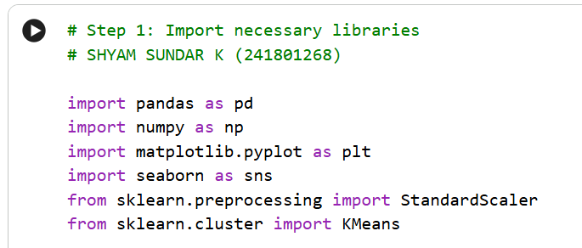
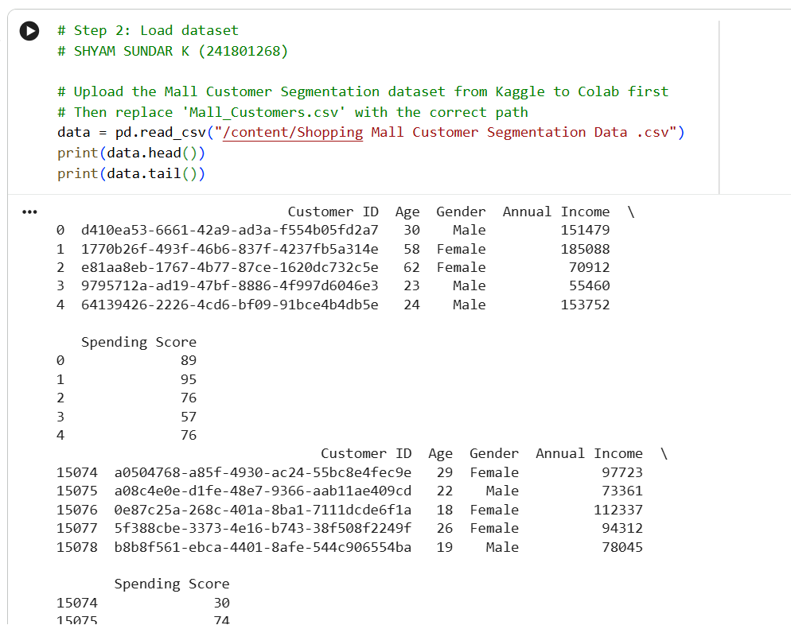
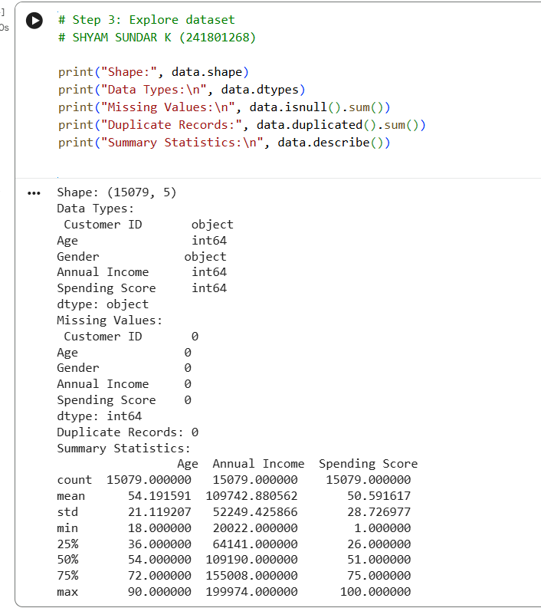
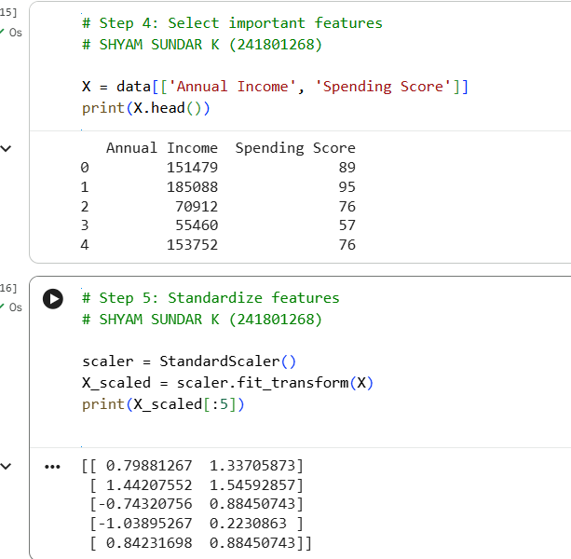
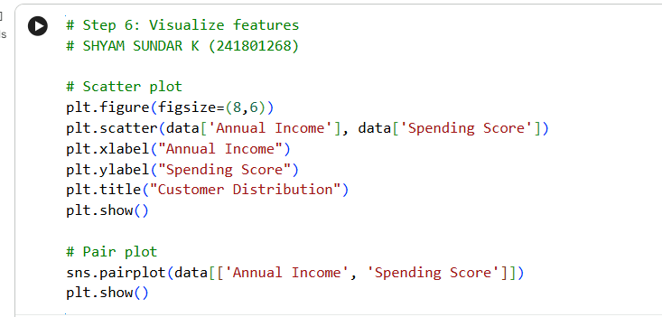
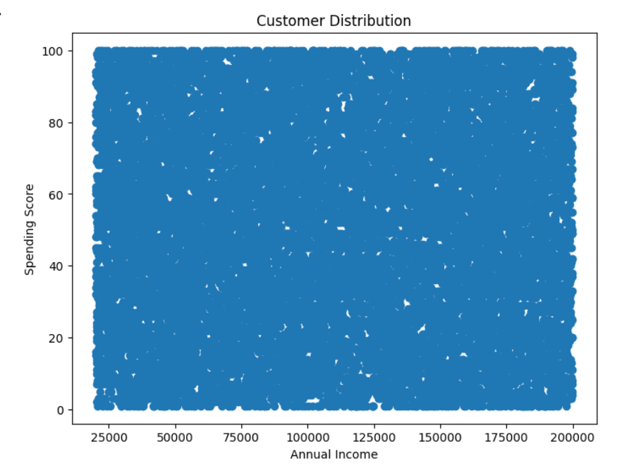
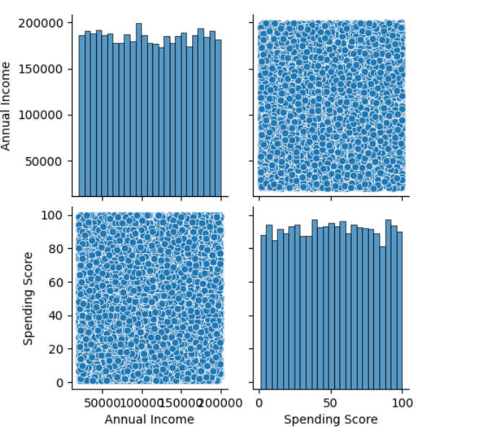
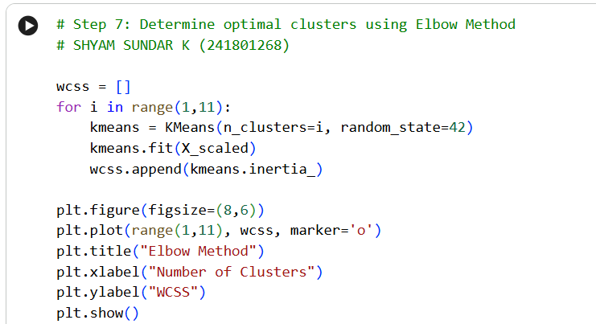
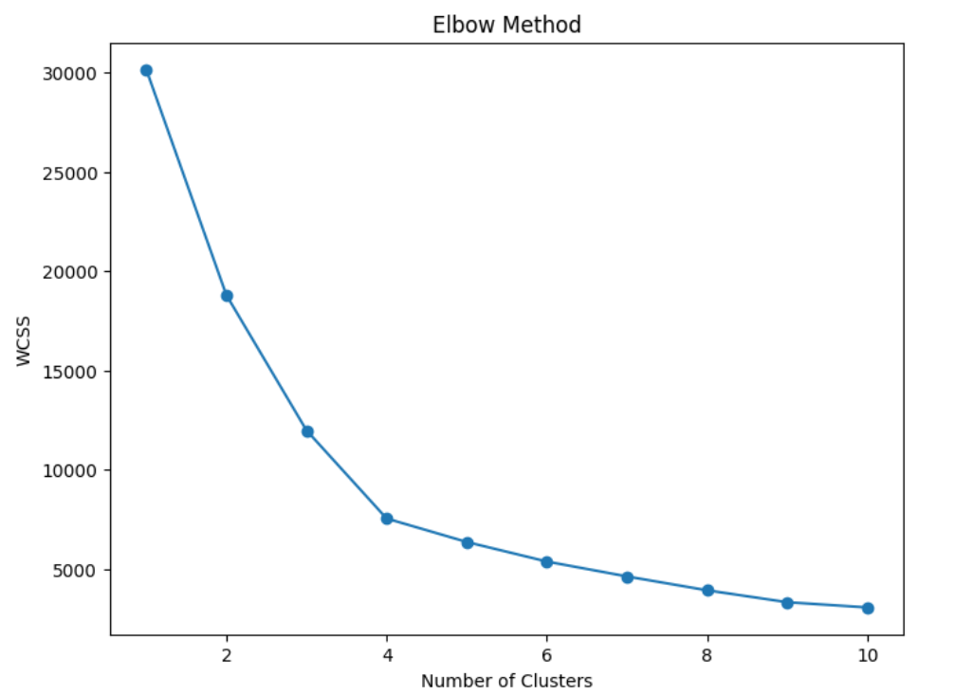
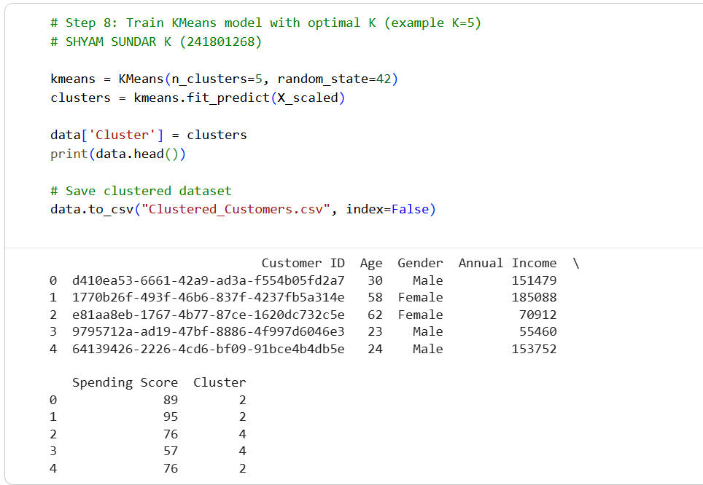
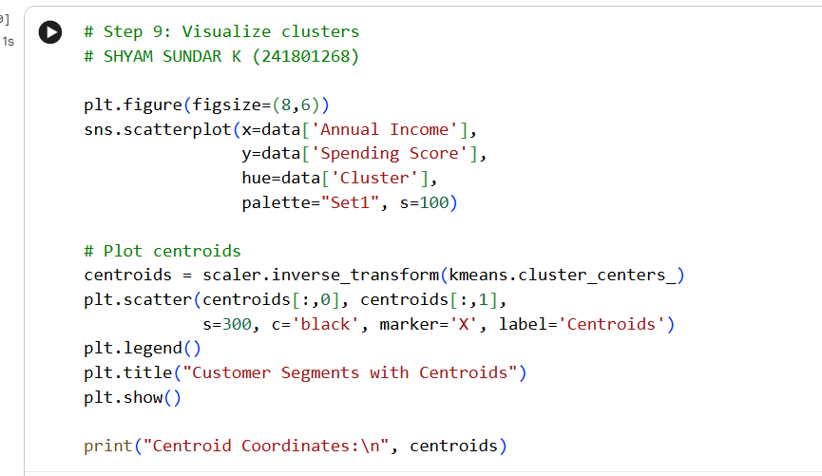
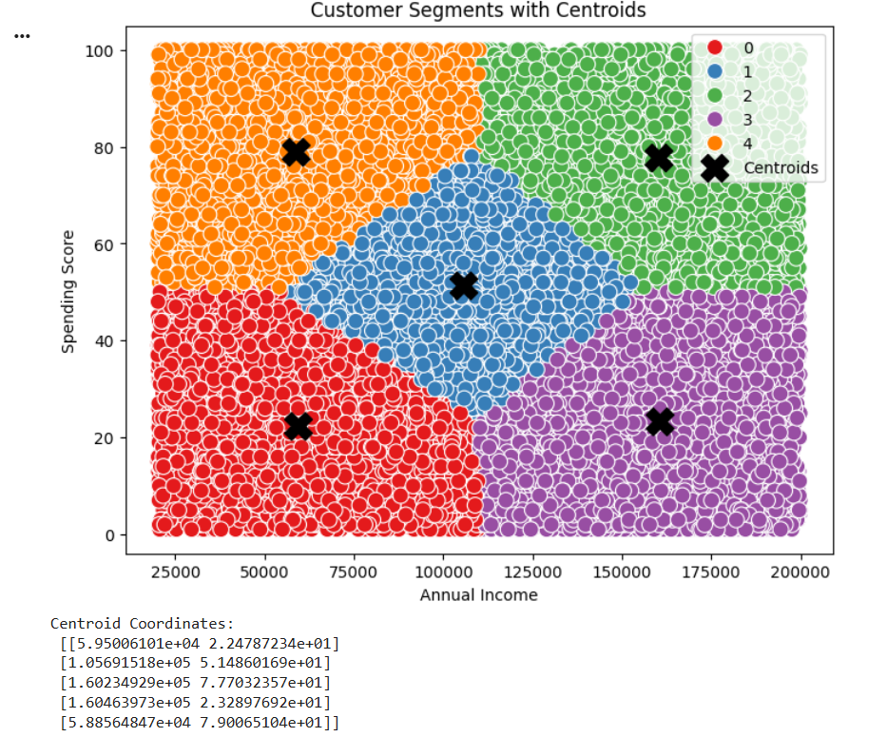
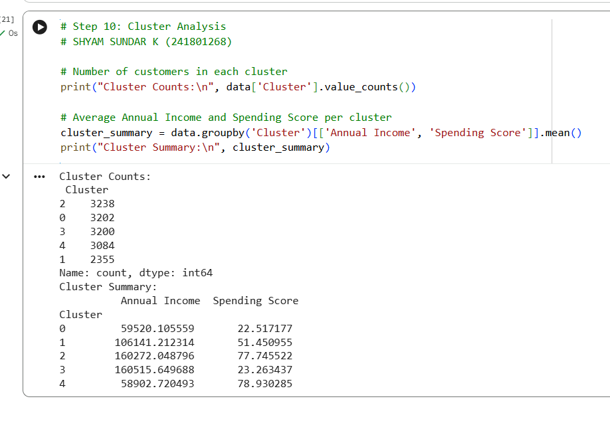

RESULT:
Thus, customer segmentation was successfully performed on the Mall Customer Segmentation dataset using the K-Means Clustering algorithm. The optimal number of clusters was analyzed using the Elbow Method, and customers were grouped based on Annual Income and Spending Score. The clusters and their centroids were visualized, customer counts and average cluster characteristics were calculated, and suitable marketing strategies were recommended for each customer segment.

